**Tensor Flow**

I created an online database using firebase. In the android studio I created a new project using product details as MainActivity and added a new activity of customer details in the same MainActivity. It's as follows

ProductDetails as MainActivity:

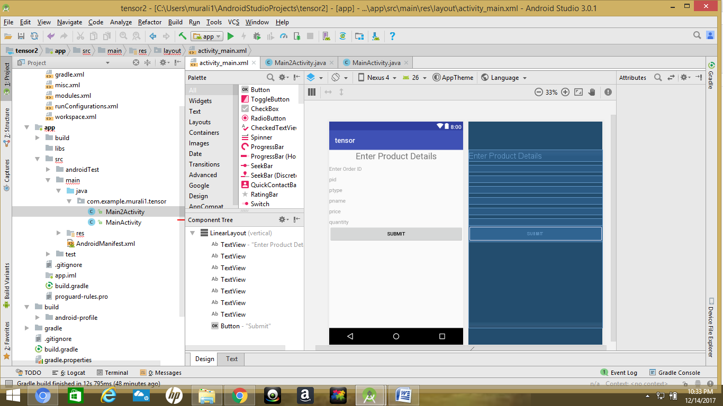

CustomerDetails as part in MainActivity:

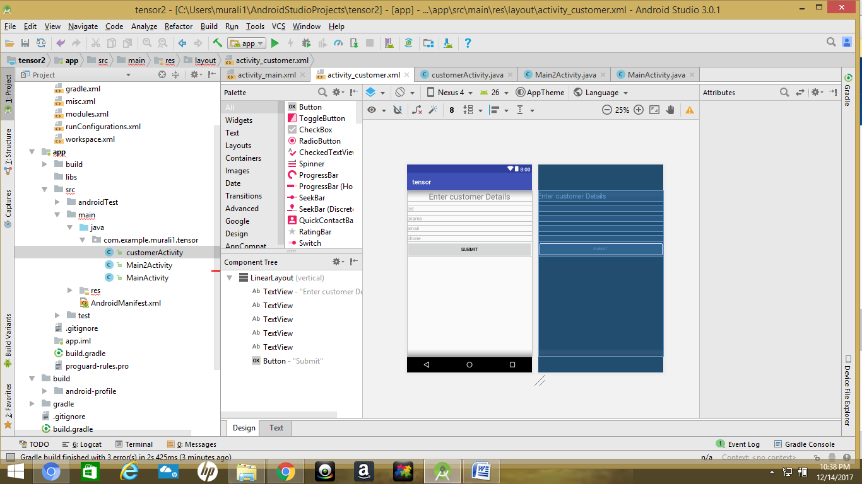

Then I connected to firebase using Android studio tools. I clicked on to Real time Data Base and also add to real time database to your app it as follows:

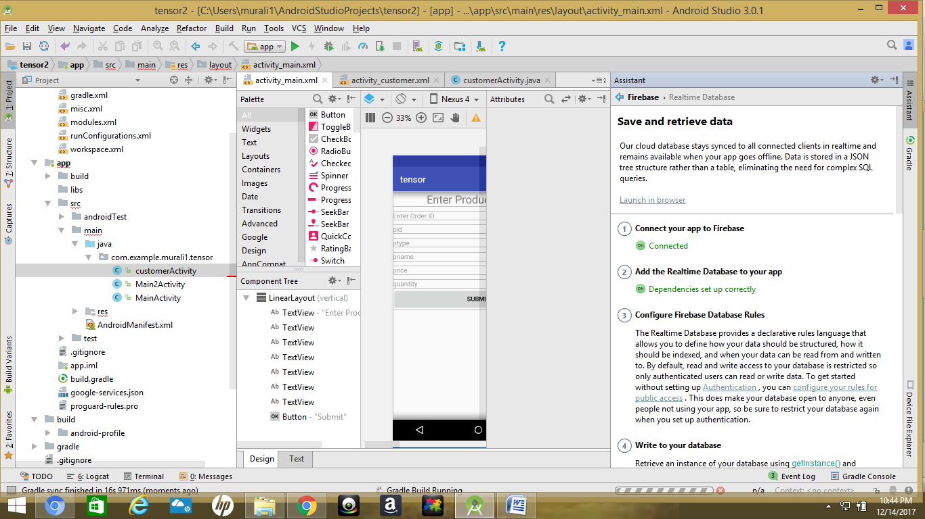

Then a webpage opens in the browser as firebase as shown:

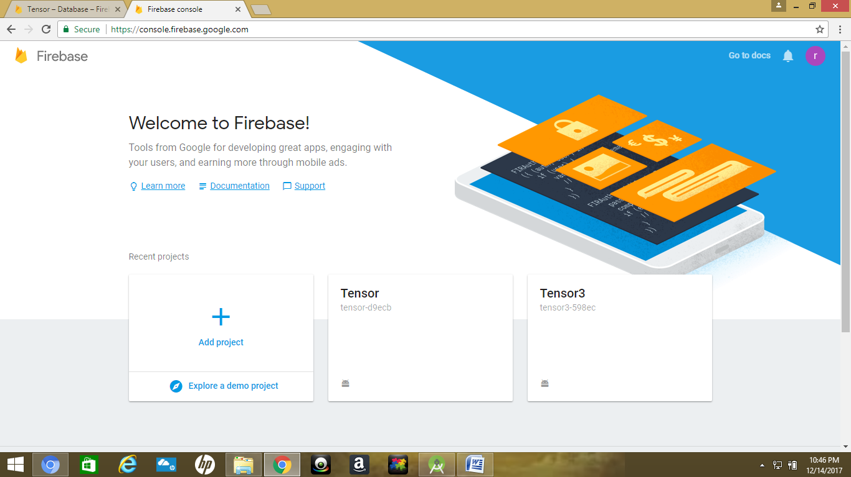

Click on Tensor and now go to Downloads where we have data base to create tables as follows:

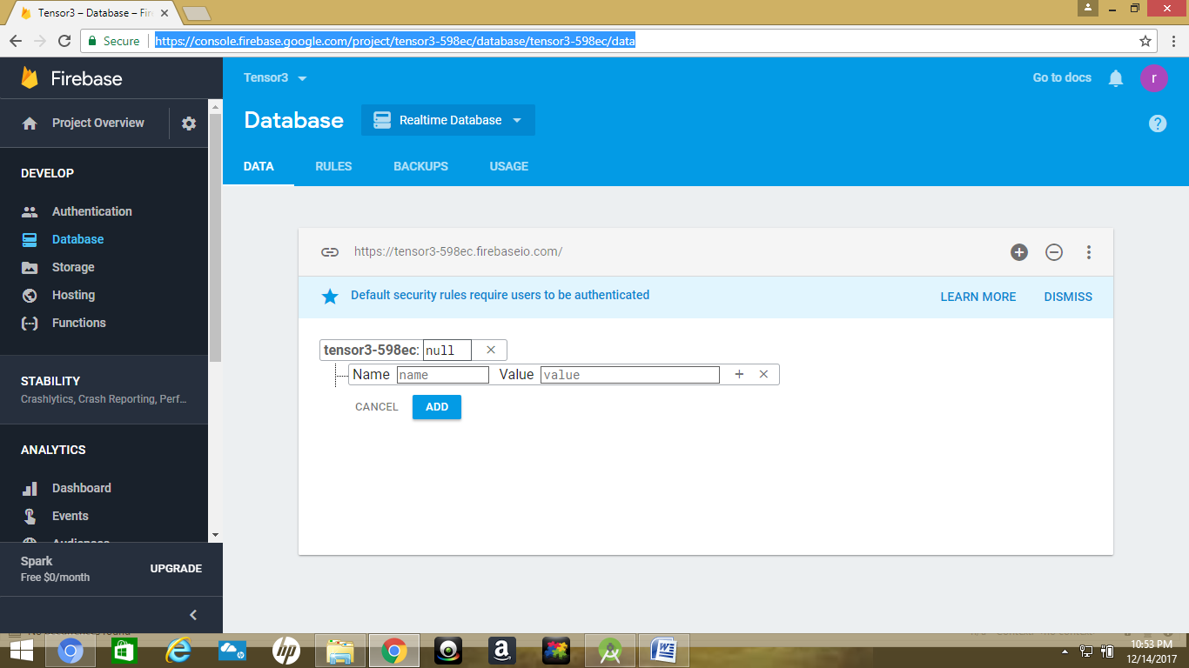

Now entering the customer and product details as follows:

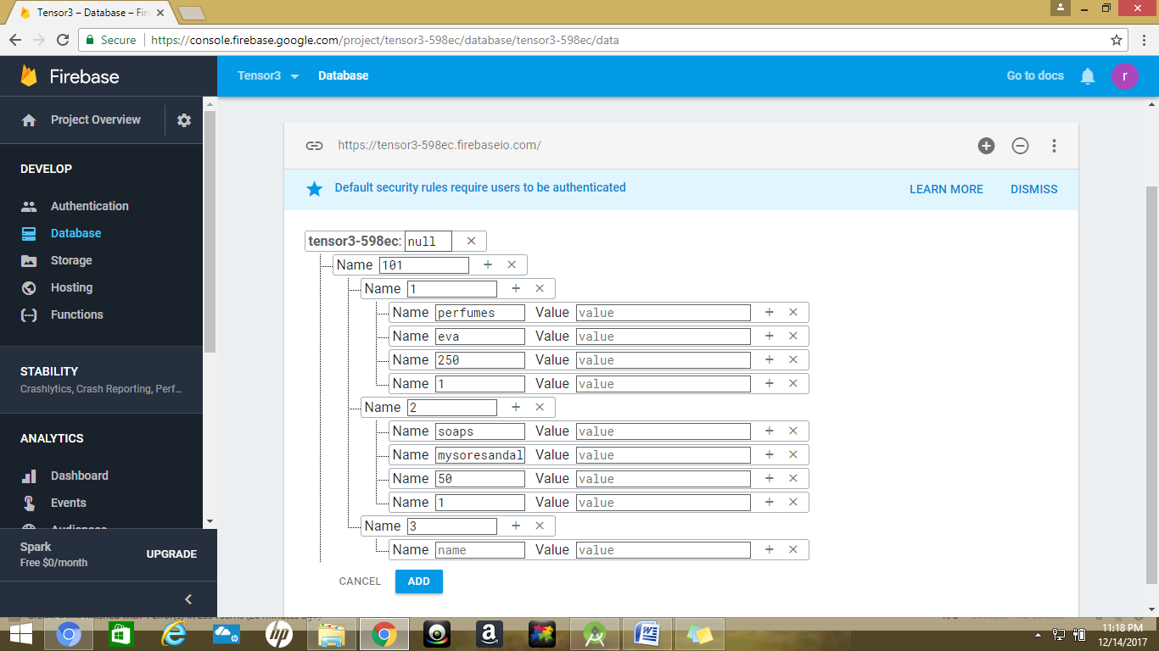

To get the table details are present in link: https://console.firebase.google.com/project/tensor3-598ec/database/tensor3-598ec/data